- Problem + Algorithm
Experiment No.: 08
Title: Simulated Annealing for Function Optimization
Aim:
Implement Simulated Annealing to minimize a given objective function.
Problem Statement:
Find the value of x in the interval [−10, 10] that minimizes the multimodal function f(x) = x² + 10 sin(x). The sine term creates several local minima around the parabola, so a simple descent method can get trapped. Simulated Annealing escapes local minima by occasionally accepting worse solutions with probability exp(−Δ/T), where T is the current temperature.
Algorithm:
- Initialize solution: choose a starting point x within the bounds [−10, 10] and evaluate f(x).
- Set initial temperature (T = 100), cooling rate (0.95), minimum temperature (0.001) and number of iterations per temperature (100).
- Generate neighboring solution: new_x = current_x + random value in [−1, 1], clipped to the bounds.
- Calculate change in objective function: Δ = f(new_x) − f(current_x).
- Accept/reject according to probability: accept if Δ < 0; otherwise accept with probability exp(−Δ/T).
- Reduce temperature: T = T × cooling rate, after every 100 iterations.
- Repeat until stopping criterion (T ≤ 0.001).
- Return best solution found (best_x and best_value).
- Program
Important sections of the program (q8_SA.py):
Function definition and key parameter settings
def f(x):
return x**2 + 10 * math.sin(x)

lower_bound = -10
upper_bound = 10
temperature = 100
cooling_rate = 0.95
min_temperature = 0.001
iterations = 100 # iterations per temperature level

Core algorithm
while temperature > min_temperature:
for i in range(iterations):
new_x = current_x + random.uniform(-1, 1) # neighbour
new_x = max(lower_bound, min(upper_bound, new_x))
new_value = f(new_x)
delta = new_value - current_value

if delta < 0 or random.random() < math.exp(-delta / temperature):
current_x = new_x # accept
current_value = new_value

if current_value < best_value: # track best
best_x = current_x
best_value = current_value

temperature *= cooling_rate # cooling

The complete executable program can be maintained digitally through Github.
- Output + Analysis
Objective Function:
f(x) = x² + 10 sin(x)
Search Interval:
−10 ≤ x ≤ 10
Initial Solution: x₀ = 2.7885 (random start in [−10, 10], seed 42)
Initial Temperature: T₀ = 100
Cooling Rate: 0.95
Iterations per Temperature: 100 (22,500 iterations in total until T ≤ 0.001)
Program Execution
Final Optimal Solution:
x* = -1.3064
Minimum Function Value:
f(x*) = -7.9458
Execution Status: Successfully Executed
Initial Solution : 2.7885
Initial Fitness : 11.2336
Iteration 100
Current Solution : -1.7735
Current Fitness : -6.6501
Iteration 1000
Current Solution : 5.4923
Current Fitness : 23.0551
Iteration 5000
Current Solution : 3.5969
Current Fitness : 8.5403
Iteration 10000
Current Solution : -1.4503
Current Fitness : -7.8241
Iteration 20000
Current Solution : -1.2982
Current Fitness : -7.9454
Final Solution : -1.3064
Minimum Value : -7.9458

Convergence Graph
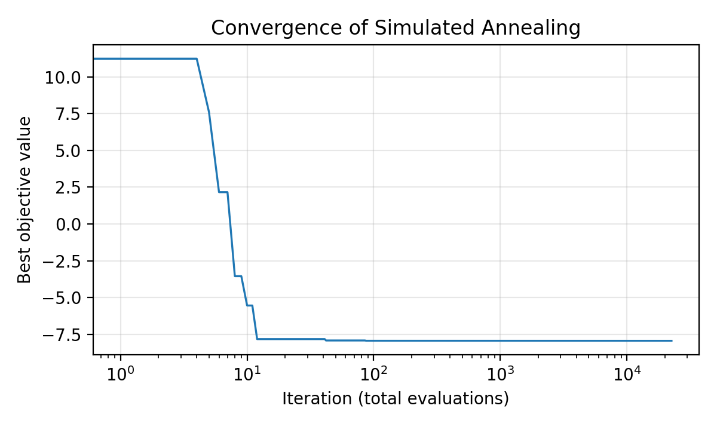
Figure: Convergence of Simulated Annealing
- X-axis → Iteration (log scale)
- Y-axis → Best objective-function value
The best-so-far value drops steeply within the first ~100 evaluations (to about −7.94) and then only fine-tunes at about −7.9458. The current solution (see the iteration log) keeps wandering while the temperature is high, accepting worse moves to explore, and settles at x ≈ −1.30 only as the temperature becomes low.
Parameter Modification
S. No. | Parameter | Original Value | Modified Value | Original Result | Modified Result | Observation
1 | Initial Temperature T0 | 100 | 50 | x = -1.3064  f(x) = -7.9458 | x = -1.3065  f(x) = -7.9458 | Lower T0 gives slightly less exploration; same minimum reached
2 | Cooling Rate α | 0.95 | 0.80 | x = -1.3064  f(x) = -7.9458 | x = -1.3062  f(x) = -7.9458 | Faster cooling uses 5,200 iterations instead of 22,500; converges sooner, with less safety against local minima
3 | Iterations per Temperature | 100 | 500 | x = -1.3064  f(x) = -7.9458 | x = -1.3064  f(x) = -7.9458 | More iterations give a more thorough search (112,500 evaluations) with no further gain here
4 | Initial Solution x0 | 2.7885 (random) | 2 | x = -1.3064  f(x) = -7.9458 | x = -1.3069  f(x) = -7.9458 | Different start gives the same global minimum; the method is insensitive to the starting point

Conclusion: Simulated Annealing located the global minimum x ≈ −1.3064, f(x) ≈ −7.9458 in every case. Results are from a run with random seed 42; values in the last decimal place can differ between runs.

- Problem + Algorithm
Experiment No.: 09
Title: Genetic Algorithm for the Travelling Salesman Problem
Aim:
Implement a Genetic Algorithm to find the shortest closed tour that visits every city exactly once.
Problem Statement:
A salesman must visit five cities, located at (0,0), (2,6), (5,3), (6,7) and (8,2), exactly once and return to the starting city. Using Euclidean distances, find the tour with the minimum total distance. A tour is encoded as a permutation of the city numbers 0–4, and its fitness is the total tour distance (smaller is better).
Algorithm:
- Initialize population: create 50 random tours (permutations of the cities).
- Evaluate fitness: compute the total distance of each tour.
- Selection: choose parents by tournament selection (3 random tours, the shortest wins).
- Crossover: apply ordered crossover – copy a segment from parent 1 and fill the remaining positions in the order of parent 2.
- Mutation: with probability 0.1, swap two randomly chosen cities.
- Elitism: copy the best tour of the previous generation unchanged into the new population.
- Replace the population with the new generation and update the best tour.
- Repeat for 200 generations (stopping criterion).
- Return the best tour and its distance.
- Program
Important sections of the program (q9_GA.py):
Function definitions and key parameter settings
cities = {0: (0, 0), 1: (2, 6), 2: (5, 3), 3: (6, 7), 4: (8, 2)}

def tour_distance(tour):
total = 0
for i in range(len(tour)):
city1 = tour[i]
city2 = tour[(i + 1) % len(tour)] # wraps back to start
total += distance(city1, city2)
return total

population_size = 50
generations = 200
mutation_rate = 0.1
tournament_size = 3

Genetic operators
def selection(population): # tournament
candidates = random.sample(population, tournament_size)
return min(candidates, key=tour_distance)

def crossover(parent1, parent2): # ordered crossover
start, end = sorted(random.sample(range(num_cities), 2))
child = [None] * num_cities
child[start:end + 1] = parent1[start:end + 1]
remaining = [c for c in parent2 if c not in child]
j = 0
for i in range(num_cities):
if child[i] is None:
child[i] = remaining[j]; j += 1
return child

def mutate(tour): # swap mutation
if random.random() < mutation_rate:
i, j = random.sample(range(num_cities), 2)
tour[i], tour[j] = tour[j], tour[i]
return tour

Core algorithm
for generation in range(generations):
new_population = [best_tour.copy()] # elitism
while len(new_population) < population_size:
parent1 = selection(population)
parent2 = selection(population)
child = mutate(crossover(parent1, parent2))
new_population.append(child)
population = new_population

current_best = min(population, key=tour_distance)
if tour_distance(current_best) < best_distance:
best_tour = current_best.copy()
best_distance = tour_distance(current_best)

The complete executable program can be maintained digitally through Github.
- Output + Analysis
Objective Function:
Minimize total tour distance: D = Σ d(city i, city i+1), including the return to the start city.
Cities (x, y):
0 (0,0), 1 (2,6), 2 (5,3), 3 (6,7), 4 (8,2)
Population Size: 50
Generations: 200
Mutation Rate: 0.1
Tournament Size: 3
Program Execution
Final Optimal Solution:
Best tour: 4 → 2 → 0 → 1 → 3 → 4
Minimum Tour Distance:
D = 24.83
Execution Status: Successfully Executed
Generation 20: Best distance = 24.83
Generation 40: Best distance = 24.83
Generation 60: Best distance = 24.83
Generation 80: Best distance = 24.83
Generation 100: Best distance = 24.83
Generation 120: Best distance = 24.83
Generation 140: Best distance = 24.83
Generation 160: Best distance = 24.83
Generation 180: Best distance = 24.83
Generation 200: Best distance = 24.83
Best tour: [4, 2, 0, 1, 3, 4]
Shortest distance found: 24.83
Brute-force check (all 12 distinct tours): 24.83

Convergence Graph
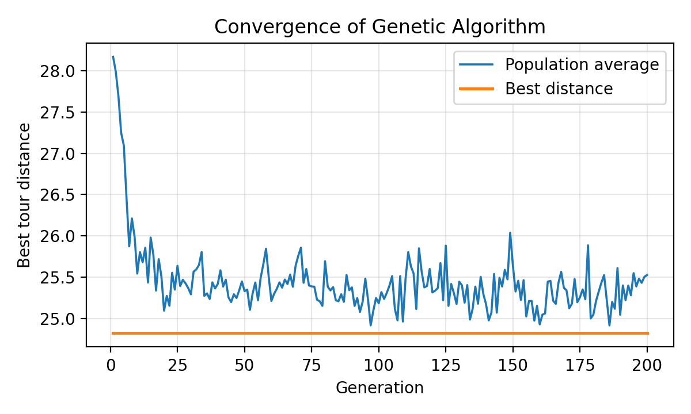
Figure: Convergence of Genetic Algorithm
- X-axis → Generation
- Y-axis → Tour distance (best and population average)
With only five cities there are just 12 distinct tours, so the best tour (24.83) was already present in the initial population and the best-distance line is flat from generation 1. The convergence is visible in the population average, which falls from about 28.2 to about 25.5 as selection and crossover fill the population with good tours.
Parameter Modification
S. No. | Parameter | Original Value | Modified Value | Original Result | Modified Result | Observation
1 | Population Size | 50 | 100 | D = 24.83 | D = 24.83 | More diversity; same optimum, higher cost per generation
2 | Generations | 200 | 50 | D = 24.83 | D = 24.83 | Optimum already found early; fewer generations suffice for 5 cities
3 | Mutation Rate | 0.1 | 0.3 | D = 24.83 | D = 24.83 | More exploration; no change for this small problem
4 | Tournament Size | 3 | 5 | D = 24.83 | D = 24.83 | Higher selection pressure; same result

Conclusion: The Genetic Algorithm found the tour 4 → 2 → 0 → 1 → 3 → 4 with distance 24.83, which matches the optimum confirmed by brute force. Parameter changes did not alter the result because the problem is very small; the effect would be visible on larger instances.

- Problem + Algorithm
Experiment No.: 10
Title: Particle Swarm Optimization for the Rosenbrock Function
Aim:
Implement Particle Swarm Optimization (PSO) to minimize the Rosenbrock function.
Problem Statement:
Minimize f(x, y) = (1 − x)² + 100(y − x²)² in the region −5 ≤ x, y ≤ 5. The function has a narrow curved valley that is easy to enter but hard to follow, with its global minimum f = 0 at (1, 1). A swarm of particles, each remembering its own best position and sharing the best position of the swarm, is used to search for this minimum.
Algorithm:
- Initialize 30 particles with random positions in [−5, 5] and random velocities in [−1, 1].
- Evaluate the fitness (Rosenbrock value) of each particle.
- Update each particle’s personal best position.
- Update the global best position of the swarm.
- Update velocity: v = w·v + c1·r1·(pbest − x) + c2·r2·(gbest − x).
- Update position: x = x + v, and clip it to the search bounds.
- Repeat for 1000 iterations (stopping criterion).
- Return the global best position and value.
- Program
Important sections of the program (q10_PSO.py):
Function definition and key parameter settings
def rosenbrock(position):
x = position[0]
y = position[1]
return (1 - x)**2 + 100 * (y - x**2)**2

num_particles = 30
dimensions = 2
iterations = 1000
w = 0.7 # inertia weight
c1 = 1.5 # cognitive coefficient
c2 = 1.5 # social coefficient
lower_bound, upper_bound = -5, 5

Core algorithm
for iteration in range(iterations):
for i in range(num_particles):
fitness = rosenbrock(positions[i])

if fitness < personal_best_values[i]: # personal best
personal_best_values[i] = fitness
personal_best_positions[i] = positions[i].copy()
if fitness < global_best_value: # global best
global_best_value = fitness
global_best_position = positions[i].copy()

r1 = np.random.random(dimensions)
r2 = np.random.random(dimensions)
velocities[i] = (w * velocities[i]
+ c1 * r1 * (personal_best_positions[i] - positions[i])
+ c2 * r2 * (global_best_position - positions[i]))

positions[i] = positions[i] + velocities[i]
positions[i] = np.clip(positions[i], lower_bound, upper_bound)

The complete executable program can be maintained digitally through Github.
- Output + Analysis
Objective Function:
f(x, y) = (1 − x)² + 100(y − x²)²
Search Interval:
−5 ≤ x ≤ 5, −5 ≤ y ≤ 5
Number of Particles: 30
Inertia Weight (w): 0.7
Cognitive / Social Coefficients (c1, c2): 1.5, 1.5
Maximum Iterations: 1000
Program Execution
Final Optimal Solution:
(x*, y*) = (1.0000, 1.0000)
Minimum Function Value:
f(x*, y*) = 0.00000000
Execution Status: Successfully Executed
Iteration 100: Best value = 0.00000158
Iteration 200: Best value = 0.00000000
Iteration 300: Best value = 0.00000000
Iteration 400: Best value = 0.00000000
Iteration 500: Best value = 0.00000000
Iteration 600: Best value = 0.00000000
Iteration 700: Best value = 0.00000000
Iteration 800: Best value = 0.00000000
Iteration 900: Best value = 0.00000000
Iteration 1000: Best value = 0.00000000
Optimization completed
Best x = 1.0
Best y = 1.0
Minimum function value = 0.0

Convergence Graph
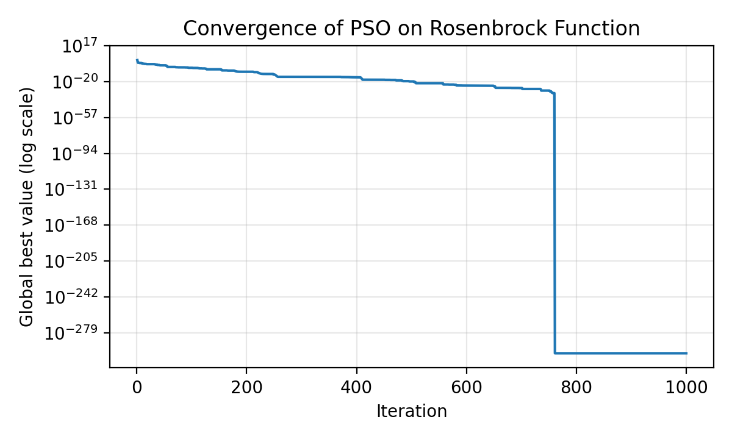
Figure: Convergence of PSO on the Rosenbrock Function
- X-axis → Iteration
- Y-axis → Global best value (logarithmic scale)
The global best value drops by many orders of magnitude (about 10⁻⁶ after 100 iterations and below 10⁻²⁵ after 600), showing that the swarm converges to the minimum at (1, 1).
Parameter Modification
S. No. | Parameter | Original Value | Modified Value | Original Result | Modified Result | Observation
1 | Inertia Weight w | 0.7 | 0.4 | f = 0  x = 1.00000  y = 1.00000 | f = 0  x = 1.00000  y = 1.00000 | Lower inertia reduces exploration; still converges
2 | c1 and c2 | 1.5 | 2.0 | f = 0  x = 1.00000  y = 1.00000 | f = 9.58e-16  x = 1.00000  y = 1.00000 | Stronger attraction; converges to within 10⁻¹⁵ of the minimum
3 | Number of Particles | 30 | 50 | f = 0  x = 1.00000  y = 1.00000 | f = 0  x = 1.00000  y = 1.00000 | More particles give better coverage; same accuracy
4 | Maximum Iterations | 1000 | 200 | f = 0  x = 1.00000  y = 1.00000 | f = 1.27e-10  x = 0.99999  y = 0.99998 | Fewer iterations leave a small error (about 10⁻¹⁰)

Conclusion: PSO reached the global minimum (1, 1) of the Rosenbrock function with an error of effectively zero within 1000 iterations. Results are from a run with random seed 42.

- Problem + Algorithm
Experiment No.: 13
Title: Ant Colony Optimization for Shortest Path Finding
Aim:
Implement Ant Colony Optimization (ACO) to find the shortest path between two nodes of a weighted graph.
Problem Statement:
A graph has five nodes (numbered 1–5 in the output) joined by weighted edges: 1–2 (2), 1–3 (4), 2–3 (1), 2–4 (7), 3–4 (3), 3–5 (5) and 4–5 (2). Find the shortest path from node 1 to node 5. Artificial ants build paths probabilistically using pheromone and distance information, and the pheromone is reinforced on short paths.
Algorithm:
- Initialize the pheromone matrix to 1 and compute heuristic information η = 1/distance for every edge.
- Place each of the 10 ants at the start node.
- Each ant moves to an unvisited neighbouring node with probability proportional to τ^α · η^β until it reaches the end node.
- Compute the length of every path that reached the end node and update the best path found.
- Evaporate pheromone: τ = (1 − ρ)·τ.
- Deposit pheromone on every edge of each successful path: Δτ = Q / path length.
- Repeat for 100 iterations (stopping criterion).
- Return the best path and its distance.
- Program
Important sections of the program (q13_ACO.py):
Graph and key parameter settings
graph = np.array([
[0, 2, 4, 0, 0], # 0 means no direct connection
[2, 0, 1, 7, 0],
[4, 1, 0, 3, 5],
[0, 7, 3, 0, 2],
[0, 0, 5, 2, 0]])
start, end = 0, 4

num_ants = 10
iterations = 100
alpha = 1 # pheromone importance
beta = 2 # distance importance
evaporation = 0.5
Q = 100

pheromone = np.ones((n, n))
heuristic[i][j] = 1 / graph[i][j] # for every existing edge

Core algorithm
for iteration in range(iterations):
for ant in range(num_ants):
path = [start]; visited = {start}; current = start
while current != end:
neighbors = [j for j in range(n)
if graph[current][j] > 0 and j not in visited]
if not neighbors:
break
probabilities = [(pheromone[current][j] ** alpha) *
(heuristic[current][j] ** beta)
for j in neighbors]
total = sum(probabilities)
probabilities = [p / total for p in probabilities]
next_node = random.choices(neighbors,
weights=probabilities, k=1)[0]
path.append(next_node); visited.add(next_node)
current = next_node
# (path length computed and best path updated here)

pheromone *= (1 - evaporation) # evaporation
for path, distance in zip(paths, distances): # deposit
for i in range(len(path) - 1):
a, b = path[i], path[i + 1]
pheromone[a][b] += Q / distance
pheromone[b][a] += Q / distance

The complete executable program can be maintained digitally through Github.
- Output + Analysis
Objective Function:
Minimize the total path length from node 1 to node 5.
Start / End Node:
Node 1 (index 0) → Node 5 (index 4)
Number of Ants: 10
Pheromone / Distance Importance (α, β): 1, 2
Evaporation Rate: 0.5
Pheromone Constant Q: 100
Maximum Iterations: 100
Program Execution
Final Optimal Solution:
Best path: 1 → 2 → 3 → 4 → 5
Minimum Path Length:
D = 8
Execution Status: Successfully Executed
Best path: [1, 2, 3, 4, 5]
Shortest distance found: 8
Mean path length of the ants in iteration 1: 8.0 (best path found in iteration 1)

Convergence Graph
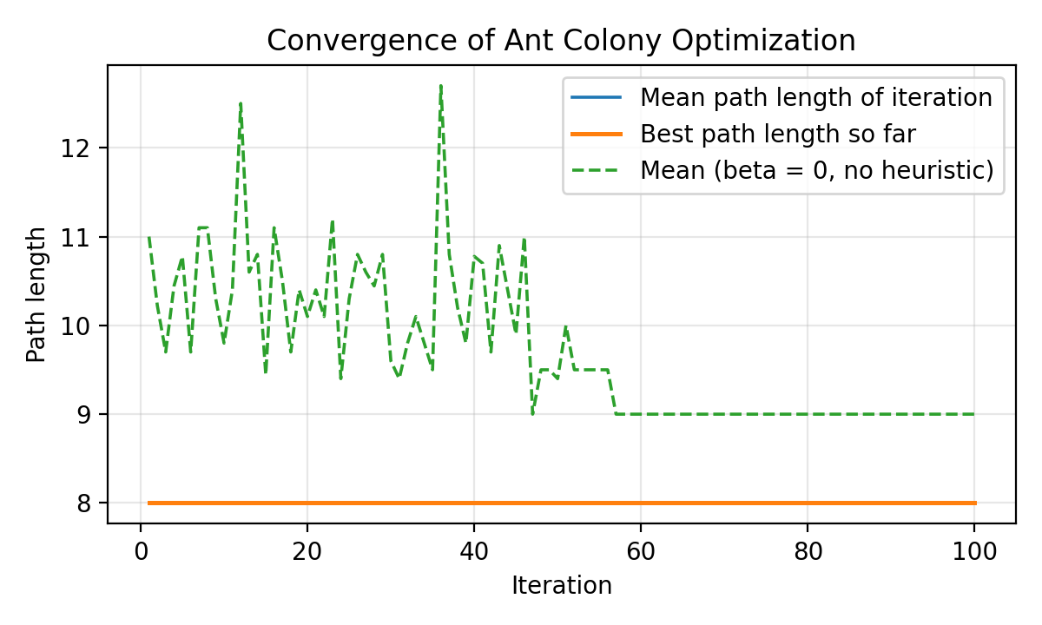
Figure: Convergence of Ant Colony Optimization
- X-axis → Iteration
- Y-axis → Path length
With β = 2 the distance information strongly favours the short edges, so the ants find the shortest path (length 8) in the very first iteration and pheromone then reinforces it. The dashed curve (β = 0, pheromone only) shows the learning effect: the mean path length falls from 11.0 to 9.0 as pheromone builds up on shorter routes.
Parameter Modification
S. No. | Parameter | Original Value | Modified Value | Original Result | Modified Result | Observation
1 | Number of Ants | 10 | 20 | 1 → 2 → 3 → 4 → 5  D = 8 | 1 → 2 → 3 → 4 → 5  D = 8 | More ants explore more paths per iteration; same result
2 | Evaporation Rate | 0.5 | 0.1 | 1 → 2 → 3 → 4 → 5  D = 8 | 1 → 2 → 3 → 4 → 5  D = 8 | Slower evaporation keeps pheromone longer; same result
3 | Distance Importance β | 2 | 0 | 1 → 2 → 3 → 4 → 5  D = 8 | 1 → 2 → 3 → 5  D = 8 | Without heuristic the ants rely on pheromone only; finds an equal-length path (1-2-3-5)
4 | Maximum Iterations | 100 | 10 | 1 → 2 → 3 → 4 → 5  D = 8 | 1 → 2 → 3 → 4 → 5  D = 8 | Solution is found early; 10 iterations suffice here

Conclusion: ACO found a shortest path of length 8. Two paths have this length (1-2-3-4-5 and 1-2-3-5), so either is a correct answer. Results are from a run with random seed 42.

